

**Ministry Of Higher Education**

**Sri Lanka Institute of Advanced Technological** **Education (SLIATE)**

Advanced Technological Institute

Anuradhapura

**Higher National Diploma in Information Technology**

**Database Document**

(Easymart.lk website)

**(**HNDIT 2304)

**Project (Group-07)**

**Supervisor: Mrs. Nadeeshani Aththanaoda**

**Academic Year: 2019/2020 Year-II, Semester 01**

**Group members**

|  |  |
| --- | --- |
| **Register no:** | **signature** |
| **ANU/IT/2019/F/0055 (GROUP LEADER)** |  |
| **ANU/IT/2019/F/0008** |  |
| **ANU/IT/2019/F/0071** |  |
| **ANU/IT/2019/F/0030** |  |
| **ANU/IT/2019/F/0037** |  |
| **ANU/IT/2019/F/0021** |  |

Table of content

1. Introduction…………………………………………………………………………..
   1. Purpose………………………………………………………………………….
   2. Scope, approach and methods…………………………………………………..
2. ER diagram…………………………………………………………………………..
3. ER to relational mapping…………………………………………………………….
4. Normalization………………………………………………………………………..
   1. UN formation……………………………………………………………………
   2. 1st normalization…………………………………………………………………
   3. 2nd normalization………………………………………………………………..
   4. 3rd normalization…………………………………………………………………
   5. Final structure……………………………………………………………………
5. Introduction

Our website consists o Five Faces, which are Homepage, Stock, New rivals, Feature brands, Contact us.

You can view computer parts prices, sales details, discounts, new available stocks, out of stocks details using this website.

You can easy to use buy computer peripherals using this web site.

You can also use to home delivery system

A comment system is running to get the user feedback about the system.

Create a data base system buying & selling computer pats use the website & also for the comments section

* 1. Purpose

The purpose of the Database Design Document that maps the logical data model to the target database management system with consideration to the system’s performance requirement. The database design converts logical or conceptual data construct to physical storage construct of the target database management system.

Document objective:

1. Describe the design of a database, that is, collection of related data stores in one or more computerized files that can be accessed by users via DBMS.
2. Serve as a basis for implementing the database and related software units. It provides acquirer visibility into the design and provides information necessary for software development.
3. Describe database design steps, including determine the proper steps in creating entities, applying normalization, selecting a Database Management System.
4. Provide expected data volumes, functional/non-functional usage of tables.
   1. Scope, approach and methods

Today the world is dominated by web. Every business is now conducted globally using the web. In this digital world, the online presence on the web is very important for every organization to advertise, promote and sell their products and services to worldwide user.

**A structured approach of our web site designing process consists of following important phases:**

1.Discovery & Planning.

2.Design & UI Coding.

3. Development.

4.Quality Control.

5.User Acceptance Testing.

6.Launch.

1. 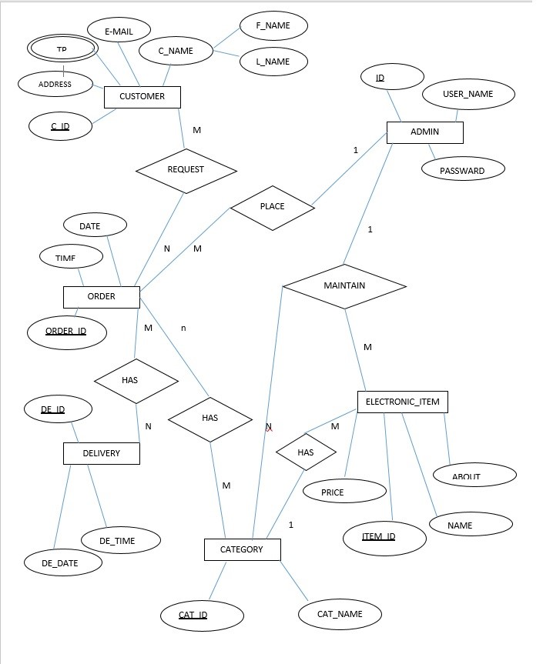ER ER to relational mapping

**Relational Mapping**

**Customer**

|  |  |  |  |  |  |  |
| --- | --- | --- | --- | --- | --- | --- |
| C-Id | F-name | L-name | Address | Telephone | E-mail | Order-Id |

**Order**

|  |  |  |  |  |  |  |
| --- | --- | --- | --- | --- | --- | --- |
| Order-Id | Date | Time | C-Id | Admin-Id | Cat-Id | De-Id |

**Category**

|  |  |  |  |  |
| --- | --- | --- | --- | --- |
| Cat-Id | Cat-name | Order-Id | Item-Id | Admin-Id |

**Delivery**

|  |  |  |  |
| --- | --- | --- | --- |
| De-Id | De-Date | De-Time | Order-Id |

**Electronic Item**

|  |  |  |  |  |
| --- | --- | --- | --- | --- |
| Item-Id | Name | About | Price | Admin-Id |

**Admin**

|  |  |  |
| --- | --- | --- |
| Admin-Id | Username | Password |

1. Normalization
   1. UN formation

Customer

|  |  |  |  |  |  |  |
| --- | --- | --- | --- | --- | --- | --- |
| C_ID | F_Name | L_Name | Address | Telephone | Email | Order_ID |

Order

|  |  |  |  |
| --- | --- | --- | --- |
| Order_ID | Date | Time | Admin_ID |

Category

|  |  |  |
| --- | --- | --- |
| Category ID | Category_ Name | Admin_ID |

Delivery

|  |  |  |  |
| --- | --- | --- | --- |
| Delivery_ID | Delivery_Date | Delivery Time | Admin_ID |

Electronic Item

|  |  |  |  |  |
| --- | --- | --- | --- | --- |
| Item_ID | Item_Name | About | Price | Admin_ID |

Admin Id

|  |  |  |
| --- | --- | --- |
| Admin_ID | User_Name | Password |

* 1. . 1st normalization

Avoid multivalued attributes and composite attributes.

CUSTOMER

|  |  |  |  |  |  |
| --- | --- | --- | --- | --- | --- |
| C_ID | F_NAME | L_NAME | ADRESS | EMAIL | ORDER_ID |

|  |  |
| --- | --- |
| C_ID | TELEPHONE |

CUSTOMER PHONE

ORDER

|  |  |  |  |
| --- | --- | --- | --- |
| ORDER_ID | DATE | TIME | ADMIN_ID |

CATAGORY

|  |  |  |
| --- | --- | --- |
| CAT_ID | CAT_NAME | ADMIN_ID |

DELIVERY

|  |  |  |  |
| --- | --- | --- | --- |
| DE_ID | DE_DATE | DE_TIME | ORDER_ID |

ELECTRONIC ITEM

|  |  |  |  |  |
| --- | --- | --- | --- | --- |
| ITEM_ID | NAME | ABOUT | PRICE | ADMIN_ID |

ADMIN

|  |  |  |
| --- | --- | --- |
| ADMIN_ID | USER NAME | PASSWORD |

* 1. 2nd normalization

Removing partial dependency

CUSTOMER

|  |  |  |  |  |  |
| --- | --- | --- | --- | --- | --- |
| C_ID | F_NAME | L_NAME | ADDRESS | E-MAIL | ORDER_ID |

CUSTOMER _F_NAME

|  |  |
| --- | --- |
| C_ID | F_NAME |

CUSTOMER_ L_NAME

|  |  |
| --- | --- |
| C_ID | L_NAME |

CUSTOMER_ ADDRESS

|  |  |
| --- | --- |
| C_ID | ADDRESS |

CUSTOMER_ E-MAIL

|  |  |
| --- | --- |
| C_ID | E-MAIL |

CUSTOMER_PHONE

|  |  |
| --- | --- |
| C_ID | TP |

ORDER

|  |  |  |  |
| --- | --- | --- | --- |
| ORDER_ID | DATE | TIME | ADMIN_ID |

CATEGORY

|  |  |  |
| --- | --- | --- |
| CAT_ID | CAU_NAME | ADMIN_ID |

DELIVERY

|  |  |  |  |
| --- | --- | --- | --- |
| DE_ID | DE_DATE | DE_TIME | ORDER_ID |

ELECTRONIC_ITEM

|  |  |  |  |  |
| --- | --- | --- | --- | --- |
| ITEM_ID | NAME | ABOUT | PRICE | ADMIN_ID |

ADMIN

|  |  |  |
| --- | --- | --- |
| ADMIN_ID | USER_NAME | PASSWARD |

* 1. 3rd normalization

Removing transitive dependency.

CUSTOMER

|  |  |
| --- | --- |
| C_ID | ORDER_ID |

CUSTOMER _F_NAME

|  |  |
| --- | --- |
| C_ID | F_NAME |

CUSTOMER_ L_NAME

|  |  |
| --- | --- |
| C_ID | L_NAME |

CUSTOMER_ ADDRESS

|  |  |
| --- | --- |
| C_ID | ADDRESS |

CUSTOMER_ E-MAIL

|  |  |
| --- | --- |
| C_ID | E-MAIL |

CUSTOMER_PHONE

|  |  |
| --- | --- |
| C_ID | TP |

ORDER

|  |  |  |  |
| --- | --- | --- | --- |
| ORDER_ID | DATE | TIME | ADMIN_ID |

CATEGORY

|  |  |  |
| --- | --- | --- |
| CAT_ID | CAU_NAME | ADMIN_ID |

DELIVERY

|  |  |  |  |
| --- | --- | --- | --- |
| DE_ID | DE_DATE | DE_TIME | ORDER_ID |

ELECTRONIC_ITEM

|  |  |  |  |  |
| --- | --- | --- | --- | --- |
| ITEM_ID | NAME | ABOUT | PRICE | ADMIN_ID |

ADMIN

|  |  |  |
| --- | --- | --- |
| ADMIN_ID | USER_NAME | PASSWARD |

* 1. Final structure

The final database structure obtained after the completion of normalization process.

CUSTOMER

|  |  |
| --- | --- |
| C_ID | ORDER_ID |

CUSTOMER _F_NAME

|  |  |
| --- | --- |
| C_ID | F_NAME |

CUSTOMER_ L_NAME

|  |  |
| --- | --- |
| C_ID | L_NAME |

CUSTOMER_ ADDRESS

|  |  |
| --- | --- |
| C_ID | ADDRESS |

CUSTOMER_ E-MAIL

|  |  |
| --- | --- |
| C_ID | E-MAIL |

CUSTOMER_PHONE

|  |  |
| --- | --- |
| C_ID | TP |

ORDER

|  |  |  |  |
| --- | --- | --- | --- |
| ORDER_ID | DATE | TIME | ADMIN_ID |

CATEGORY

|  |  |  |
| --- | --- | --- |
| CAT_ID | CAU_NAME | ADMIN_ID |

DELIVERY

|  |  |  |  |
| --- | --- | --- | --- |
| DE_ID | DE_DATE | DE_TIME | ORDER_ID |

ELECTRONIC_ITEM

|  |  |  |  |  |
| --- | --- | --- | --- | --- |
| ITEM_ID | NAME | ABOUT | PRICE | ADMIN_ID |

ADMIN

|  |  |  |
| --- | --- | --- |
| ADMIN_ID | USER_NAME | PASSWARD |